**LEBANESE AMERICAN UNIVERSITY**

**USAID – HIGHER EDUCATION SCHOLARSHIP PROGRAM**

**HES - Volunteering Program Verification Form**

This form is to be used to document volunteering hours. If a student volunteers for multiple organizations, a separate form must be used for each organization. **This form must be turned in by the 28th of each month, the latest.**

I certify that the scholar Farah Al Ali completed a total of 5 hours of service at InnovaThrive.

The hours were completed hours as per the below:

Hours # 5 (date) _2/12 – 6/12_ (initials of supervisor) __A.K.___

Hours # 0 (date) _9/12 – 13/12_ (initials of supervisor) __A.K.___

Hours # 0 date) _16/12 – 20/12 (initials of supervisor) __A.K.___

Hours # 0 date) _23/12 - 27/12 (initials of supervisor) __A.K.___

Brief description of the activities the scholar performed or participated in:

My task involved writing on the topic of "AI in Enhancing Language Learning Experiences." This encompasses its definition, relevant technologies such as natural language processing (NLP) and virtual reality, as well as statistical insights, advantages, disadvantages, and potential avenues for future research.

Written feedback about the scholar’s performance:

Farah’s research on AI in language learning highlighted how technologies like NLP and virtual reality can enhance learning experiences, offering practical insights into their advantages and areas for future exploration.

Please rate the overall performance of the scholar at your organization:

|  |  |  |  |
| --- | --- | --- | --- |
|  | Mastery (5) | Proficient (3) | Emerging (1) |
| **Problem solver** | X |  |  |
| **Engaged & Committed** | X |  |  |
| **Open-minded & multicultural** | X |  |  |

Signature

& stamp

__________________________

_

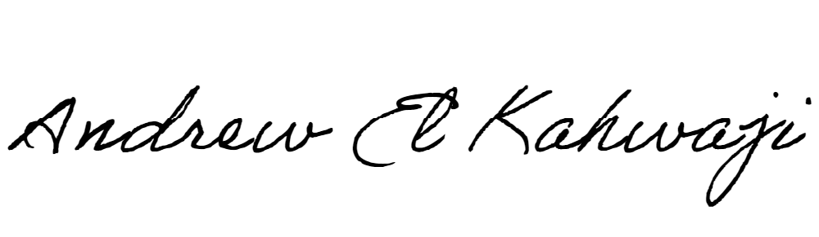

Printed Name _Andrew El Kahwaji_

Date __26/12/2024___

Email __andrew.lifesculptor.coo@gmail.com __

Phone __+961 71 914 378__